**Understanding SmartTag Structure in Workday**

**Researching Cost Center and Fund**

**For new SmartTag requests**

In Workday, we have funds and cost centers similar to how we had funds and org codes in Banner. Cost centers are centered around departments; they are essentially subsets of a department.  The Workday replacement for index (SmartTag) is similar to Banner as well.

As you may already be aware, Cost Center hierarchy is the key to the new structure in Workday. It is important for you to understand the hierarchy so that you can manage your department’s funds and activities. At the top level, the hundreds of cost centers roll up into the collection of ALL FAU Cost Centers. At the bottom level are the actual cost centers. The levels in between make up the hierarchy, where access, reporting, etc. are controlled.

Level 5 Cost Center Hierarchy is the lowest-level grouping of cost centers in Workday.  It is the level at which we are assigning roles for viewing budget to actual reporting and it is intended to organize Cost Centers into Departments.  The next level up, Level 4, organizes cost centers by college (for the academic side of FAU).  Again, this allows for reporting and role assignments to be done on a hierarchy level for a group of related cost centers.

SmartTag represents a short-cut. Workday’s structure allows us to have multiple smarttags within each cost center. This helps simplify the tracking of your funds.

For example, within one cost center *Department of Educational Leadership;* you could have several SmartTags:

1. Department of Educational Leadership (**E&G funded**)
2. CF-Department of Educational Leadership (**Carryforward funds**)
3. Department of Educational Leadership (**Foundation funded**)
4. Educational Leadership Sales (**Auxiliary funded**)

*They share a cost center (for tracking activity - revenues/expenditures/personnel) and share a cost center manager, but have different funding sources. Also because organizationally it makes sense that the business purpose of all TAGs are similar to are related to that cost center*

As another example, the Department of Educational Leadership cost center could have two E&G-funded SmartTags, one for Boca and one for Jupiter, or both SmartTags can be under the same campus and same program code.

**Do I need a New Cost Center?**

If you can’t track the activity for the new SmartTag under an existing cost center, or if it makes no sense that the business purpose of this new TAG will be similar to or is related to that cost center; then a new cost center will be needed.

**If you need a new Cost Center, please follow the instructions below to find Level*5 location that is requested on the ticket.**

**How to find the location for the New Cost Center?**

Cost Centers are set up under the lowest hierarchy, which is level 5. You will need to examine related cost centers to determine the appropriate location for your new Cost Center (and the SmartTag that will be tied to it).

Run **FAU SmartTag Finder Report**, enter your appropriate hierarchy level (e.g. College of Education *4) in the Cost Center Hierarchies prompt line.

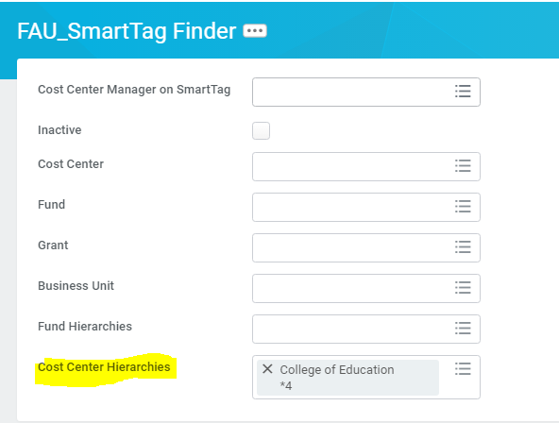

Level *5 is the level that is needed in order to setup the new Cost Center.

The CC Level *5 is essential information for your new SmartTag request in the OIT ticket system. Following the above steps will help you determine the best structure and hierarchy for your new SmartTag. Remember, access, approvals, and reporting depend on you providing the appropriate *5 hierarchy for the cost center. Reclassifying and moving actual activity after-the-fact is time consuming and tedious, we encourage you to exercise due care in the set-up steps.

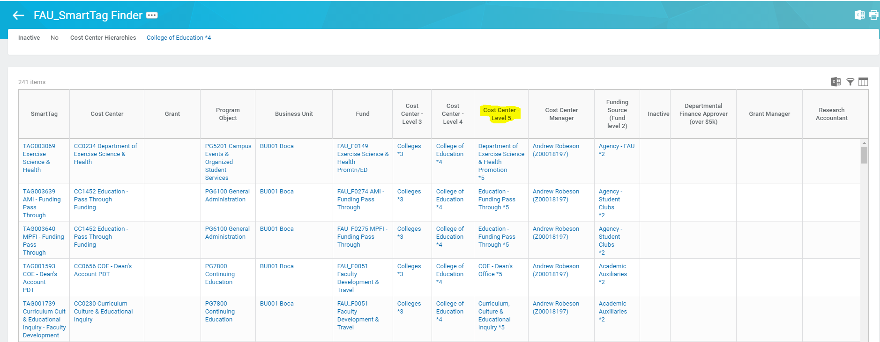

**How to find the location for your SmartTag’s Fund:**

In addition to the appropriate Cost Center for your new SmartTag, you will need to select the appropriate fund. This is simple for funds such as GTAIDS (FAU_F0000) and Carryforward (FAU_F0019). However, this has been a little more challenging for some of the other fund types, especially Auxiliaries.

If you know you have existing smarttags that are set up within the same fund that you want to use for your new smarttag, you might find the simplest approach to be looking at your existing smarttags. Run the **FAU SmartTag Finder report**. Enter your College (College of Education *4) or your department (Honors-Social Sciences *5) in the Cost Center Hierarchies prompt line as appropriate. This will show you ALL of the SmartTags under all Cost Centers under that hierarchy level. You can then scan, or filter, by fund or by cost center, to review your current smarttags and choose one to copy that should use the same fund as your new smarttag.

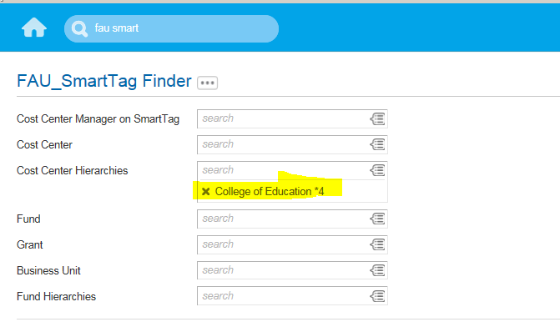

Determine the Fund (code FAU_FXXXX) you want to use for your new SmartTag by using this report.

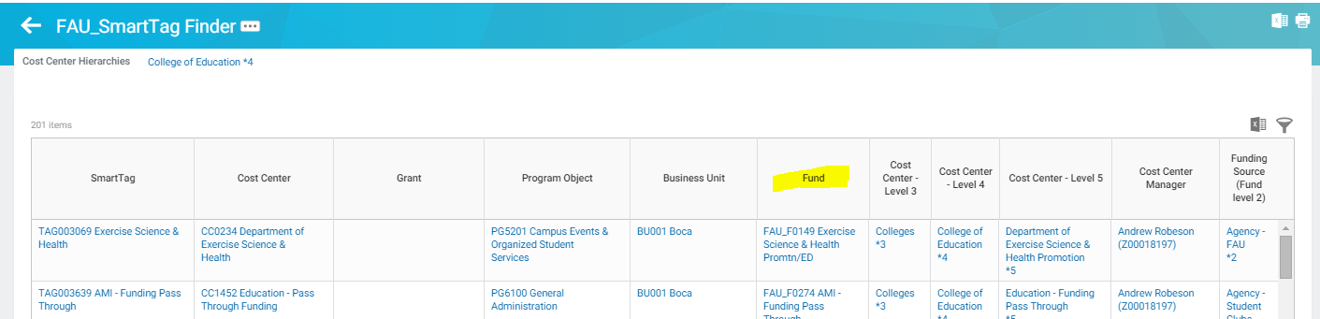

If you prefer a more visual approach to the fund hierarchy structure, try the Navigate Fund Hierarchy option.

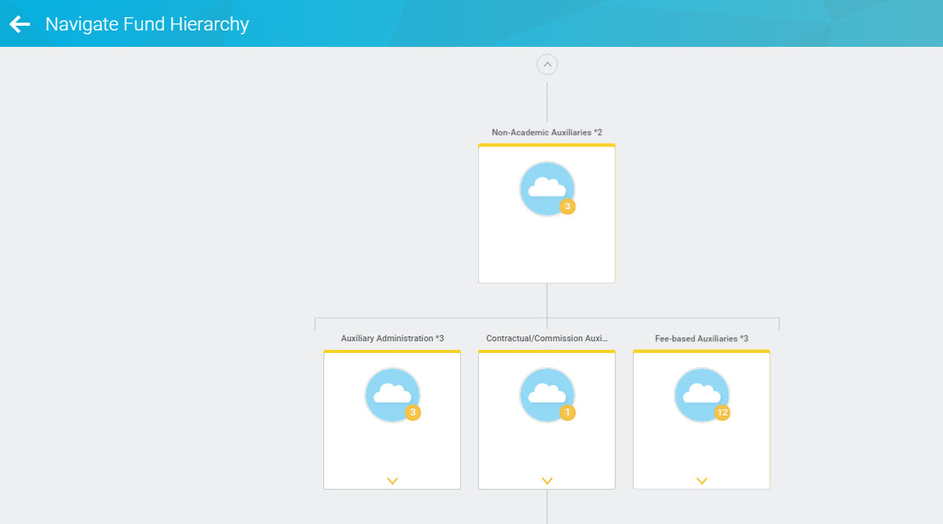

***Just remember***…….

FAU SMART TAG FINDER Report: This report will show you all SmartTags within a Cost Center hierarchy, or you can see all SmartTags using a particular cost center.

**Complete OIT Ticket Request with care:**

As you were reminded above, it is important that your new smarttag be set up properly from inception. Please take time to research each of the worktag elements (Cost Center, Fund, Program, and Business Unit) so that you provide accurate settings for your new smarttags and cost centers.

Also note that it is important to provide the appropriate authority/individual’s name for your Cost Centers so that CCManager can be configured properly for approvals, etc.